

Object Oriented
Programing

Lab 05

Structures & Recursion

Structures
Structure is a user-defined data type that allows you to combine data items of different kinds.

Structure Declaration
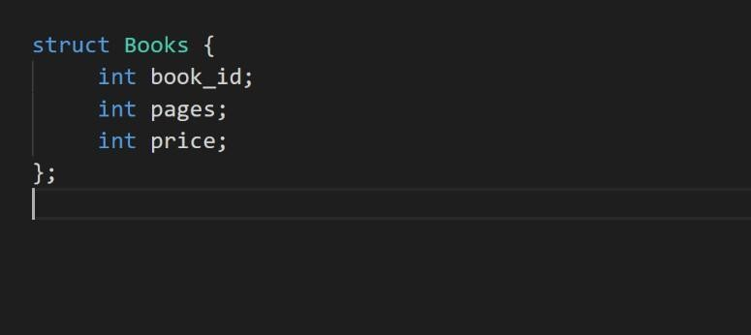
Types of Members

Structures in C++ can contain two types of members:
- Data Member: These members are normal C++ variables. We can create a structure with variables of different data types in C++.
- Member Functions: These members are normal C++ functions. Along with variables, we can also include functions inside a structure declaration.

Accessing Structure Members
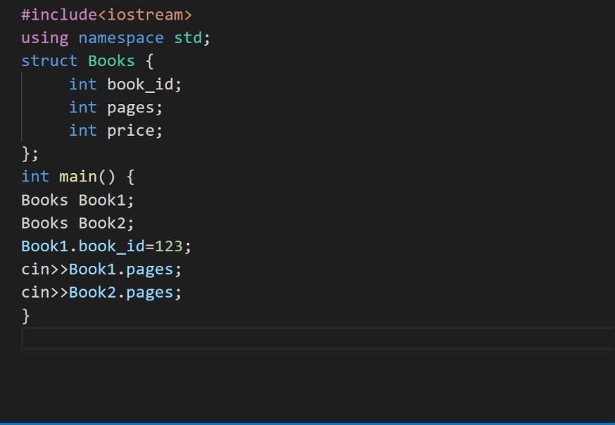

Array of Structures
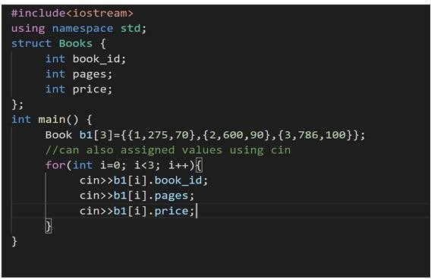
Dynamic memory allocation for structure
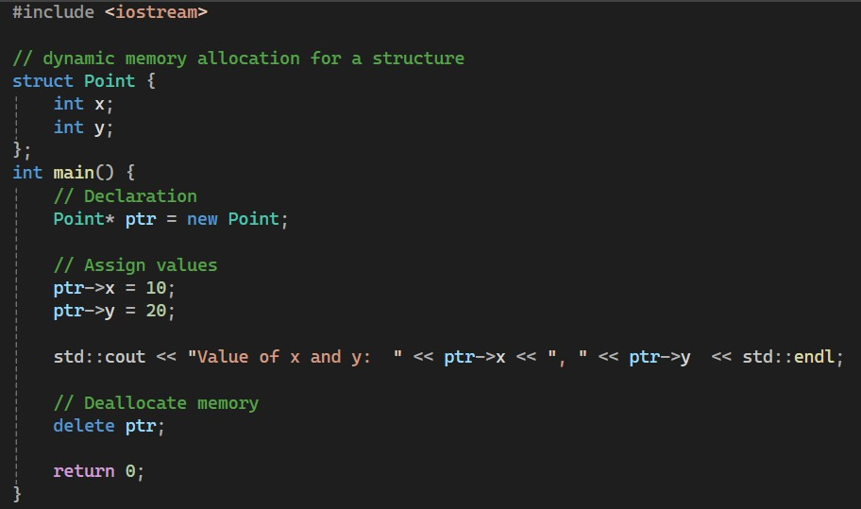
RECURSION

A recursive function is one that calls itself.

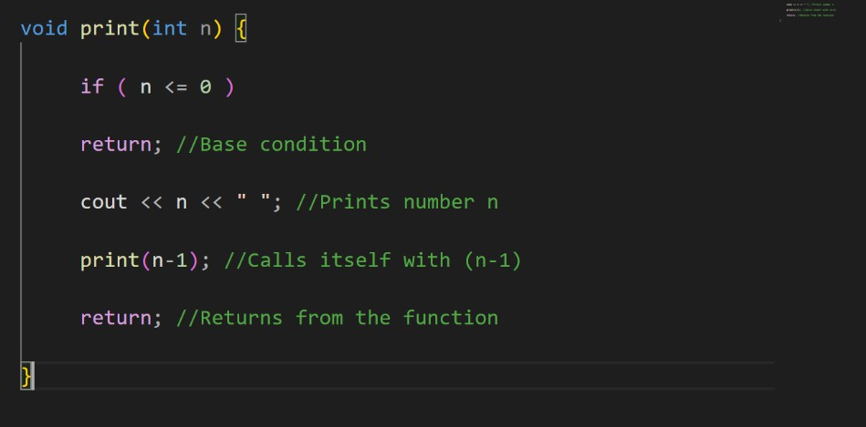Example

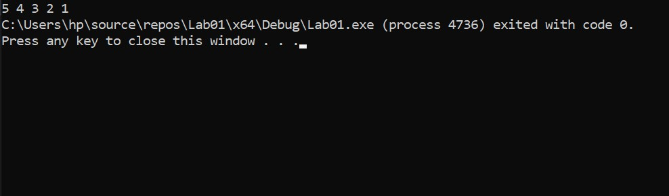Output

Lab Task

Problem 1:

Roman numerals are represented by seven different symbols: I, V, X, L, C, D and M.
Symbol Value
I 1
V 5
X 10
L 50
C 100
D 500
M 1000
For example, 2 is written as II in Roman numeral, just two ones added together. 12 is written as XII, which is simply X + II. The number 27 is written as XXVII, which is XX + V + II.
Roman numerals are usually written largest to smallest from left to right. However, the numeral for four is not IIII. Instead, the number four is written as IV. Because the one is before the five we subtract it making four. The same principle applies to the number nine, which is written as IX. There are six instances where subtraction is used:
- I can be placed before V (5) and X (10) to make 4 and 9.
- X can be placed before L (50) and C (100) to make 40 and 90.
- C can be placed before D (500) and M (1000) to make 400 and 900.
Given a roman numeral, convert it to an integer.

Example 1:
Input: s = "III"
Output: 3
Explanation: III = 3.
Example 2:
Input: s = "LVIII"
Output: 58
Explanation: L = 50, V= 5, III = 3.
Example 3:
Input: s = "MCMXCIV"
Output: 1994
Explanation: M = 1000, CM = 900, XC = 90 and IV = 4.
Prototype of Function: int romanToInt(string s)

Problem 2:

Given a string s containing just the characters '(', ')', '{', '}', '[' and ']', determine if the input string is valid.
An input string is valid if:
- Open brackets must be closed by the same type of brackets.
- Open brackets must be closed in the correct order.
- Every close bracket has a corresponding open bracket of the same type.

Example 1:
Input: s = "()"
Output: true
Example 2:
Input: s = "()[]{}"
Output: true
Example 3:
Input: s = "(]"
Output: false
Example 4:
Input: s = "([])"
Output: true
Example 5:
Input: s = "([)]"
Output: false
Prototype of Function: bool isValid(string s)

Problem 3:

You are given an unsorted array of integers. Your task is to find the length of the longest consecutive sequence of numbers that appear in increasing order. The order of elements in the array does not matter, only the sequence of increasing order matters.

Example1:

Array= {100, 4, 200, 1, 3, 2} Output= 4
Explanation: 1,2,3,4 is the longest increasing sequence in the array. (order does not matter)

Example2:

Array= {15,20,21, 1, 2, 13, 17, 16,18,19,22,24} Output= 8
Explanation: 15,16,17,18,19,20,21,22 is the longest increasing sequence in the array. (order does not matter). Other sequence is 1,2 but its smaller than the first one.

Prototype of Function: int longestConsecutive(int arr[], int size, int index, int currentMax)

Hint: Initially index and currentMax are 0;

Problem 4:

Write a recursive function to print Pascal’s Triangle of size n without using any loops. Pascal's Triangle is a triangular array of numbers in which each number is the sum of the two numbers directly above it, and the first and last elements of each row are always 1.

Examples:

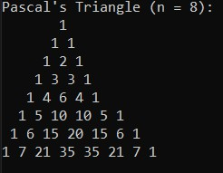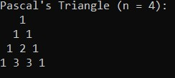

Problem 5:

- Declare a structure named Date with the following data members:
  - day of type int
  - month of type int
  - year of type int

- Write a member function named daysBetween that takes two Date objects:
Both parameters passed by value and returns the number of days between these two dates (the exact calculation can be simplified or a more accurate approach can be used; the focus is on handling the function parameters).
Prototype: int daysBetween(Date d1, Date d2);
- Write a member function named incrementDate that takes a Date object by reference and increases the date by one day (handle incrementing the day, month, and possibly year if the day overflows, e.g., from Jan 31 to Feb 1).
Prototype: void incrementDate(Date &d);

